AIM2 Exploration

Adam Jauregui

March 19, 2019

## Table of Date Typos

I created this table by taking the difference of the date values, in days, between the variables “First Hemoglobin Date” (from the lab data) and the aforementioned variable “Date of Last Referring Clinic.” If the difference was negative (i.e., the lab visit was earlier than the referral visit) or greater than 90 days, then those observations are in this table.

## Plots of Hemoglobin Paired

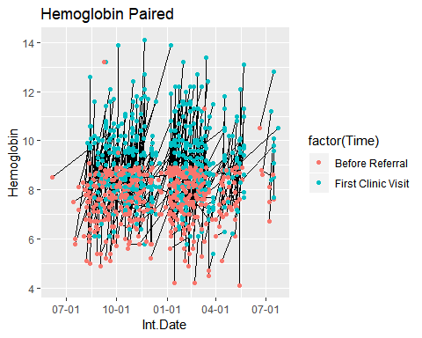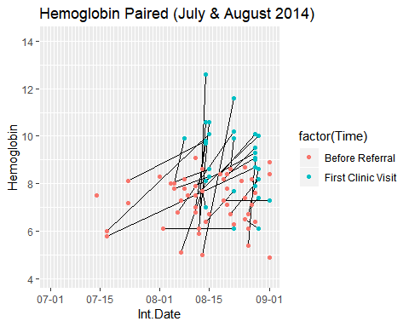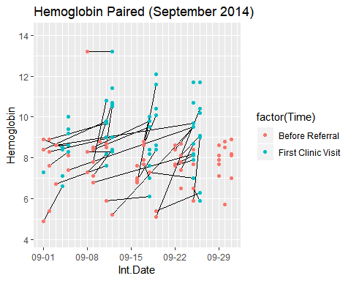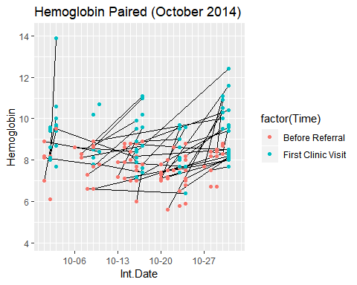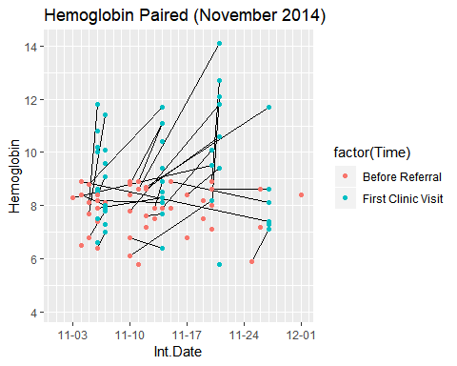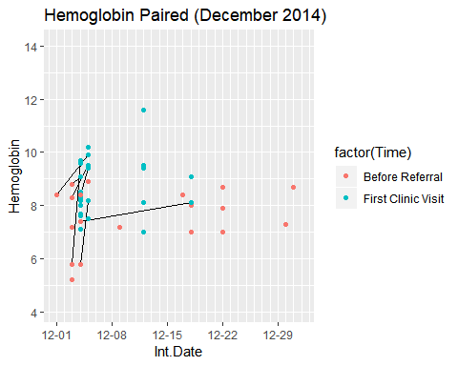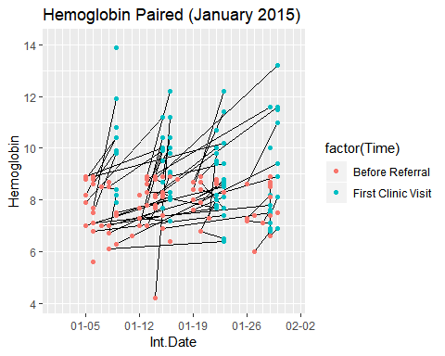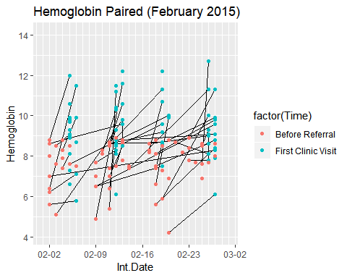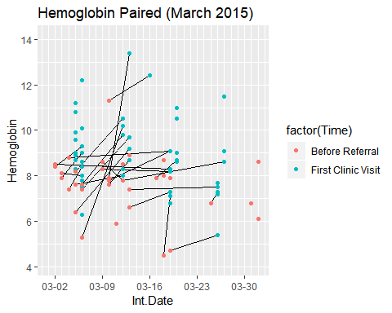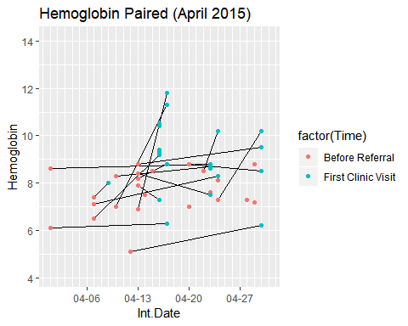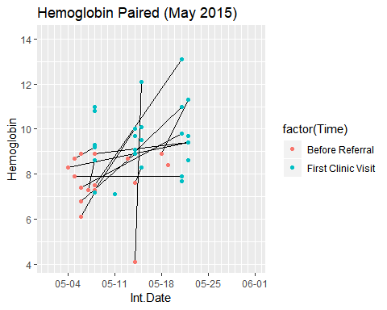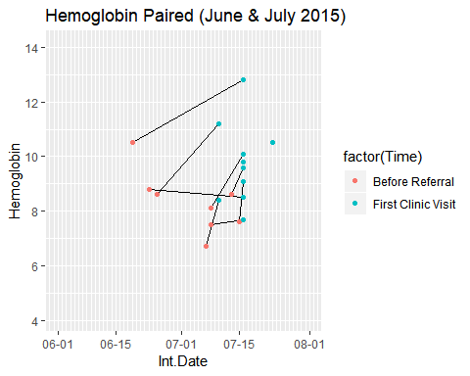

## Histograms of Hemoglobin

N = 485

Width = 0.4

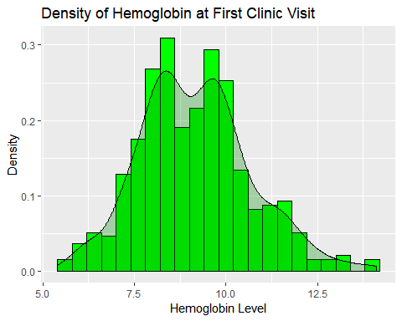

N = 484

Width = .4

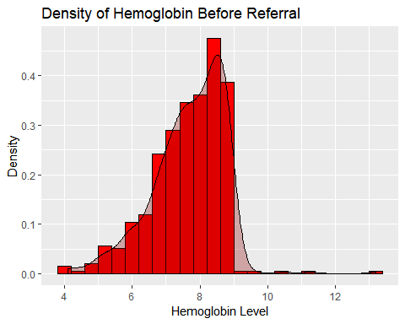

# Histograms of Hemoglobin Before Referral by Method

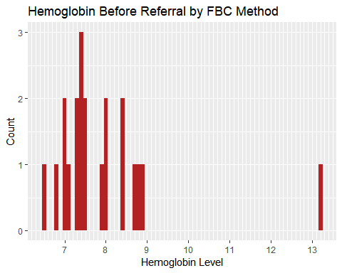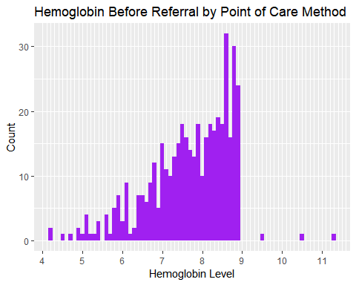

## Inclusion Criteria

## inclusion.lab  
## No Yes   
## 136 349

##   
##   
## |Included by Hgb @ Lab? |Anemia Definition | Freq| cumFreq| freqPercent| cumPercent|  
## |:----------------------|:-----------------|----:|-------:|-----------:|----------:|  
## |No |all else | 136| 136| 28.04| 28.04|  
## |Yes |all else | 163| 299| 33.61| 61.65|  
## | |Hb<10/dl:=36wks | 46| 345| 9.48| 71.13|  
## | |Hb<8g/dl | 34| 379| 7.01| 78.14|  
## | |Hb<9g/dl:HIV+ | 106| 485| 21.86| 100.00|

## Histograms of Hemoglobin Levels (Inclusion Criteria)

N = 349

Width = 0.3

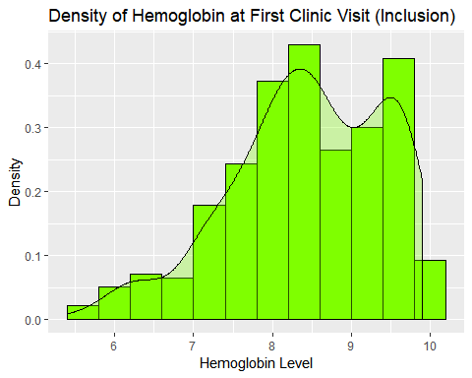

N = 348

Width = .3

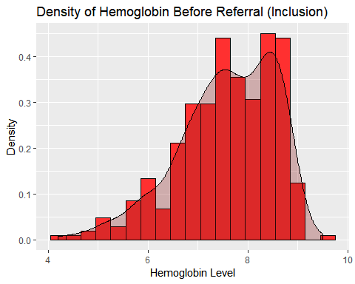

## Date Difference Histograms

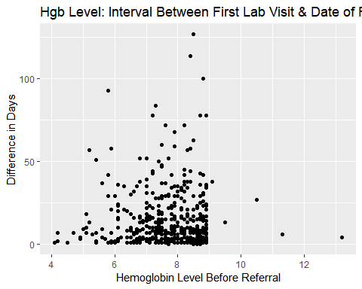

N = 482

Width = 5.784691

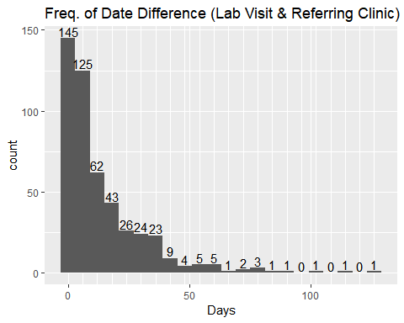

## LOESS Plot

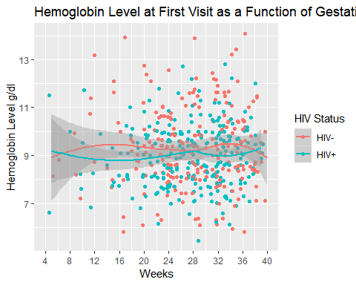

## Tables

## HIV Status Gestation Age First Visit Month ~ Median IQR Q1 Q3  
## 1 HIV- 1 8.45 0.35 8.27 8.62  
## 2 HIV- 2 9.9 2.5 8.2 10.7   
## 3 HIV- 3 8.7 3.6 8.25 11.8   
## 4 HIV- 4 9 1.30 8.4 9.7   
## 5 HIV- 5 9.5 2.22 8.38 10.6   
## 6 HIV- 6 8.95 1.73 8.1 9.83  
## 7 HIV- 7 9.2 1.95 8.3 10.2   
## 8 HIV- 8 9.4 2.3 8.1 10.4   
## 9 HIV- 9 9.5 1.9 8.4 10.3   
## 10 HIV- 10 8.55 1.45 7.82 9.28  
## 11 HIV- 20 9.25 0.75 8.88 9.62  
## 12 HIV- 21 7 0 7 7   
## 13 HIV- NA 9.1 1.75 8.65 10.4   
## 14 HIV+ 1 9.05 2.45 7.82 10.3   
## 15 HIV+ 2 8.85 2.13 7.75 9.88  
## 16 HIV+ 3 8.45 1.12 8 9.12  
## 17 HIV+ 4 9.1 1.60 8.05 9.65  
## 18 HIV+ 5 8.7 1.8 8.1 9.9   
## 19 HIV+ 6 9 1.73 8.17 9.9   
## 20 HIV+ 7 9.2 1.95 8.05 10   
## 21 HIV+ 8 9.1 1.9 7.9 9.8   
## 22 HIV+ 9 9.1 1.3 8.35 9.65  
## 23 HIV+ 22 9.8 0 9.8 9.8   
## 24 HIV+ NA 10.2 2.93 8.82 11.8

## HIV Status Gestation Age Month Median IQR Q1 Q3  
## 1 HIV+ 1 7.4 2.45 7 9.45  
## 2 HIV+ 2 8.8 2.1 7.82 9.93  
## 3 HIV+ 3 8.95 1.50 7.98 9.48  
## 4 HIV+ 4 9.1 1.9 8.2 10.1   
## 5 HIV+ 5 9.4 1.8 8.15 9.95  
## 6 HIV+ 6 9.4 2 8.4 10.4   
## 7 HIV+ 7 9.5 1.9 8.6 10.5   
## 8 HIV+ 8 9.6 1.7 8.6 10.3   
## 9 HIV+ 9 9.7 1.55 9.02 10.6   
## 10 HIV+ 10 10.3 1.3 9.6 10.9   
## 11 HIV+ 11 12.0 0.35 11.9 12.2   
## 12 HIV+ 22 9.75 0.05 9.72 9.78  
## 13 HIV+ NA 10.8 2.68 8.95 11.6   
## 14 HIV- 1 8.7 0.35 8.40 8.75  
## 15 HIV- 2 9.8 1.85 8.95 10.8   
## 16 HIV- 3 10.9 3.4 8.5 11.9   
## 17 HIV- 4 8.8 1.75 7.88 9.62  
## 18 HIV- 5 9.75 2.15 8.65 10.8   
## 19 HIV- 6 9.4 2.15 8.43 10.6   
## 20 HIV- 7 9.5 2.4 8.6 11   
## 21 HIV- 8 9.85 1.9 8.9 10.8   
## 22 HIV- 9 9.6 1.82 8.78 10.6   
## 23 HIV- 10 10.3 0.8 9.7 10.5   
## 24 HIV- 20 10 1.3 9.25 10.6   
## 25 HIV- 21 7 0 7 7   
## 26 HIV- 22 7.1 0 7.1 7.1   
## 27 HIV- NA 10.4 1.7 9.1 10.8